Introduction
The Aloha Training Managers Leader Guide provides an overview of managerial functions. Utilize this training guide when training Managers to ensure they can demonstrate each area of functionality efficiently.

Contents
ATO Screen Definitions 2
Status Ribbon 2
General Options 2
Order Methods 3
ATO Screen: Changing Quote Times 4
Manager Functions Screen 5
Initial Fingerprint Enrollment 6
Manage Drawers 8
Assign Drawer to Cashier 8
De-Assign Drawer 8
Drawer Checkout 9
Reprint Checkout 9
Delete Checkout 9
Open Drawer 9
Recall 10
Reopen Check 10
Void Item 11
Void Entire Check 11
Credit Card Refunds 12
Same Day Credit Card Refunds 12
Past Day Credit Card Refund 13
Cash Refunds - Same Day 15
Quick Refund 15
Itemized Refund 16
Partial Ticket Refund 17
Guest Detail 18
IOU's 19
Add an IOU 19
Applying an IOU Amount to an Order 19
DNS 20
Add DNS Notification 20
Remove DNS Notification 20
Maintenance Items 21
Fingerprint Enrollment 21
Change my Password 21
Clear Password 21
Calibrate 22
Reroute Printer 22
Set Destination 22
Reset to Default Configuration 22
Allow Clock In 22
Allow Clock Out 23
Delete Clock Out 23
Edit Break 23
Edit Time 24
Aloha Reports 25

ATO SCREEN DEFINITIONS
STATUS RIBBON
YELLOW ARROW TOGGLES CURRENT/ALL DAY | When highlighted displays total number of orders for each category: Online, Walk In, Call In.
CURRENT QUOTE TIMES | Current Quote time displayed for Guest to receive the order: Will be the same for each type of order.
ADJUST QUOTE TIME | Can only be adjusted by the Manager or Shift Leader or when instructed by Manager or Shift Leader.
TIME AND DATE | Current time and date.
GENERAL OPTIONS
ALOHA | Access employees and managers function screens.
ATO | Main start screen to enter phone number and name.
LOOK UP | Guest Name or Phone number entry.
ORDERS/PICK UP | Displays open orders, closed orders or all orders
FUTURE | Displays Future Orders
LOG OUT | Locks the terminal

ORDER METHODS (RIGHT SIDE OF SCREEN)
WALK IN | To be used for guests placing the order at the counter. Requires guest name and will take you directly to the Aloha screen.
CALL IN | To be used for guest calling in their order. Requires Guest Name and Phone Number.
START WEB | To be used for Online and App Orders. Requires Guest Name and Phone Number (not used).
FUTURE ORDER | To be used for walk in or call in guest, placing an order for a specific future time.  *guest information must already be in the system.
REPEAT ORDER | To be used for a regular guest that normally places the same order.
ADD GUEST | Record guest information to the system used after name and or number entered.
GUEST DETAILS | Allows to add notes to the Guest record as DNS (did not show) or future credits (IOU) given for incorrect orders.  *Notes are visible to the guest on printed receipt.

ATO SCREEN: changing quote times
The ATO screen displays quote times based on user input. These quote times can be changed to accommodate actually changing quote times. All quote times should be the same and updated on Terminal 1 to change across all systems.
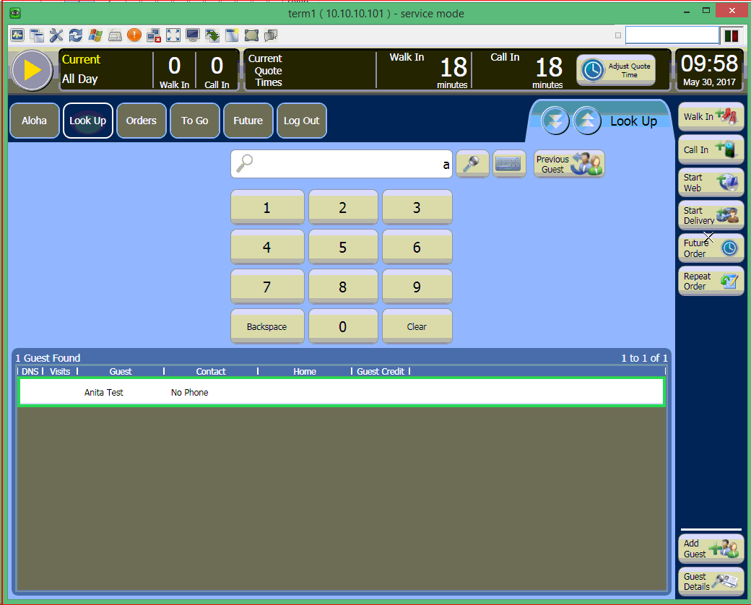
- Select Adjust Quote Times
- Use the ‘-‘ and ‘+’ buttons to adjust quote times
- Select OK to confirm
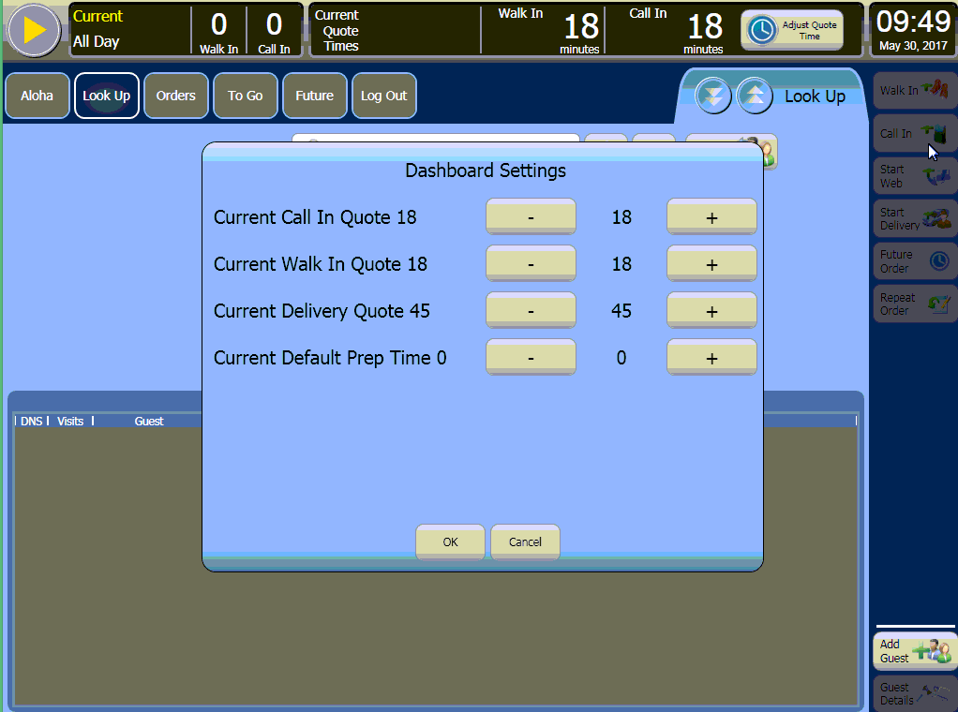

manager functions screen
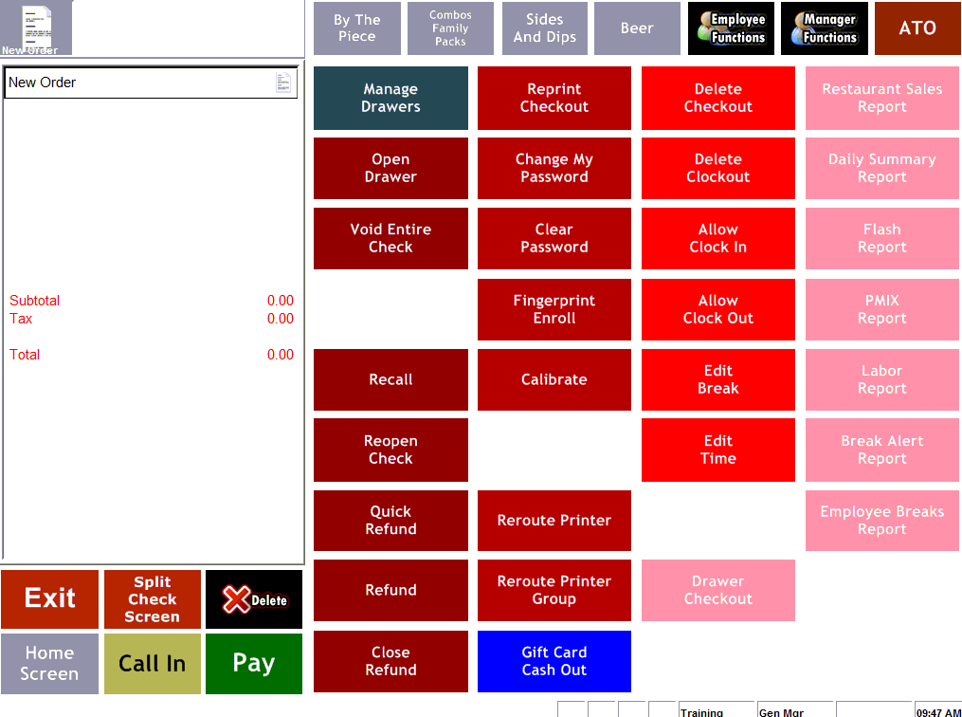

initial fingerprint enrollment
Allows the manager to create their fingerprint impression to log into Aloha Manager Functions. New Restaurant access to the Aloha POS. Managers and employees must be set up in the NCR Back Office.
- Look up the franchisee or manager’s POS code in NBO.
- Navigate to Labor Dashboard > Employee Maintenance. | 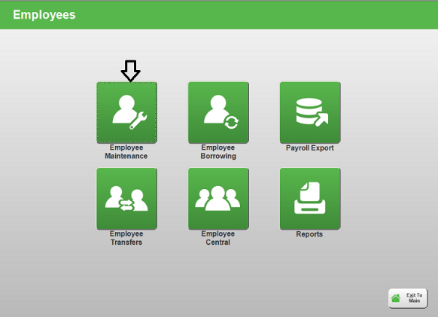
- Highlight the employee by clicking on it. | 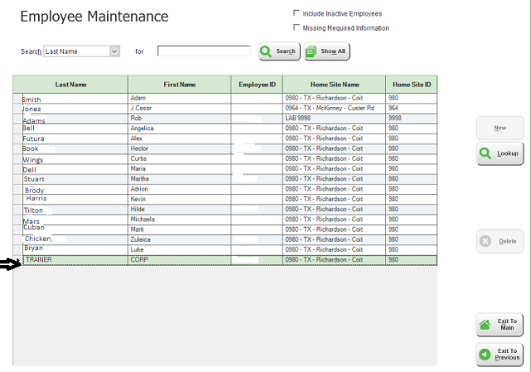
- Click the Lookup button on the right side of the screen. | 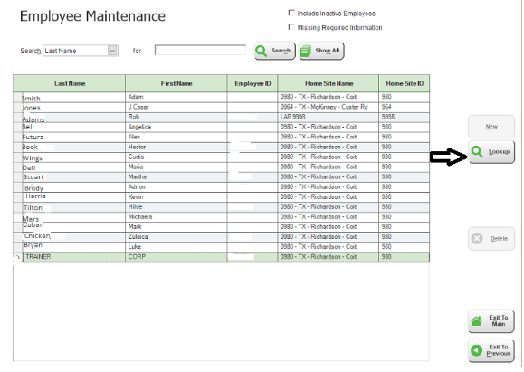
- Click on the Point of Sale tab. | 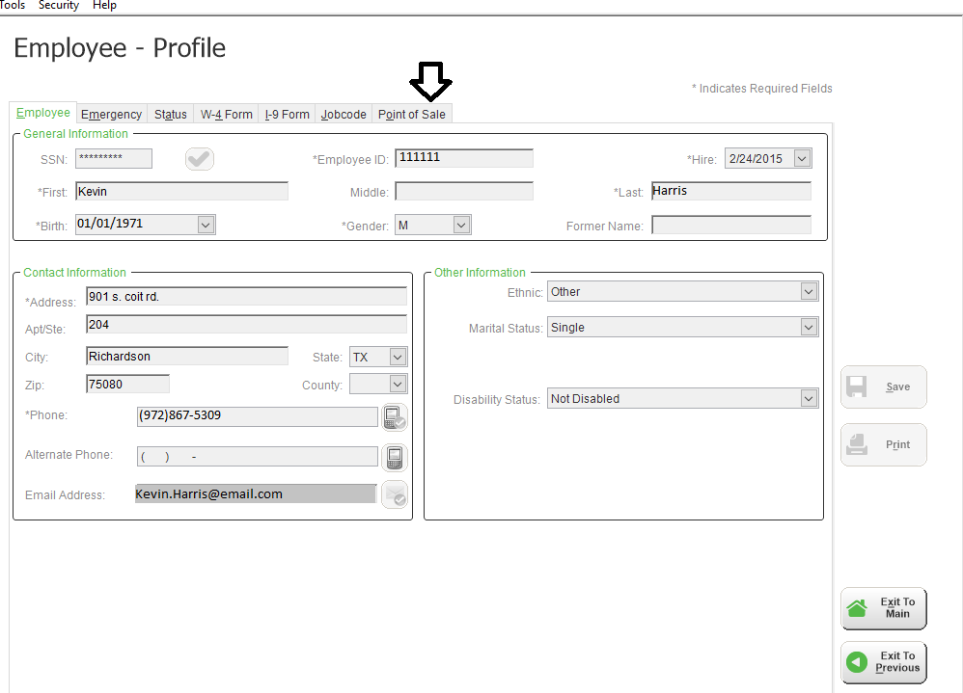
- Find their POS Code. | 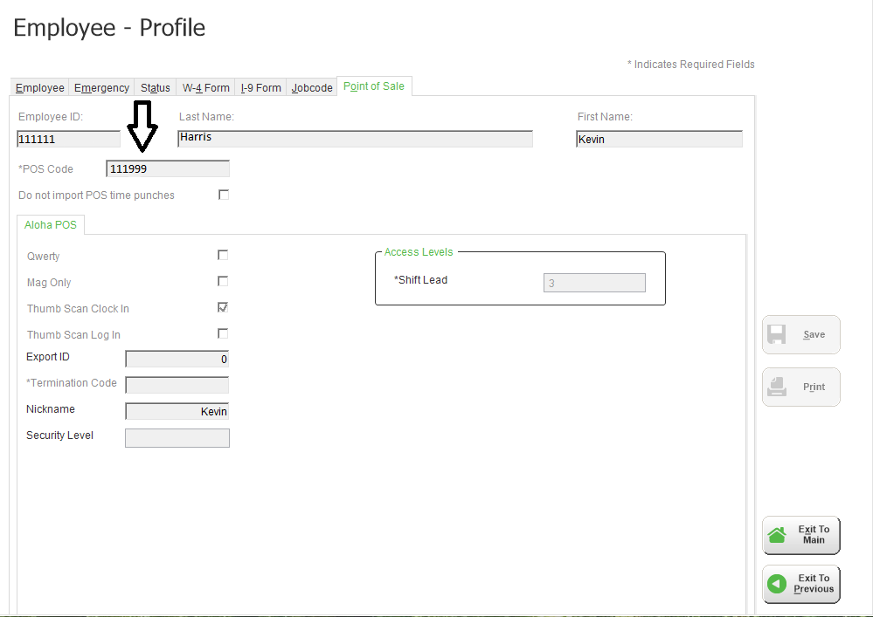
- Go to an Aloha Terminal and clock-in using the POS Code.
- Navigate to Aloha Manager Functions.
- Click Fingerprint Enrollment.
- Select the employee to enroll (yourself).
- Select OK.
- Scan fingerprint using the scanner until you have three successful attempts.
- Select OK.
- Exit.
manage drawers
Allows you to view who is assigned to all drawers, assign drawers to employees, do cash in or cash out on a drawer and verify checkout of all drawers.
assign drawer to cashier
From Manager Functions screen in Aloha:
- Select Manage Drawers
- Select the drawer that you would like to assign
- Select Assign
- To assign a drawer to a cashier:
- Select No when asked if you would like to make the draw public
- Select the employee
- Select OK
- To assign drawer as a Public drawer: (NOT RECOMMENDED)
- Select Yes when asked if you would like to make the draw public
- Enter the starting bank as the $ amount set for your location
- Select OK
- Select Done
DE-Assign drawer
Can be done without doing cashier checkout only if no money has been taken.
From Manager Functions screen in Aloha:
- Select Manage Drawers
- Select the drawer that you would like to de-assign
- Select Assign
- Select OK to confirm

drawer checkout
- On assigned drawer of employee
From Manager Functions screen in Aloha:
- Select Drawer Checkout
- Select Yes to confirm checkout on notes drawer
- Select Yes to reset the drawer totals
reprint checkout
From Manager Functions screen in Aloha:
- Select Manager Functions
- Select Reprint Checkout
- Select the employee
- Select OK
delete checkout
Delete a checkout from current day.
From Manager Functions screen in Aloha:
- Select Delete Checkout
- Select the employee
- Select OK
open drawer
From Manager Functions screen in Aloha:
- Select Open Drawer
- Select drawer to open
- Select OK

RECALL
Recall will allow to search for a recall a closed check from a selected terminal.
From the ATO screen:
- Select Manager Functions
- Select Recall
- Select a terminal
- Select OK
- Select the ticket to open
- Select OK
REopen check
Reopen a closed check.
From the ATO screen:
- Select the Orders tab
- Select the Closed tab
- Find and Select the Closed check
- Select Modify
- Select Manager Functions
- Select Reopen check

void item (after sent to kitchen, not paid)
From the Aloha Screen within the order
- Select Item to Void
- Select Delete
- Utilize Fingerprint for manager approval
- Select Reason
- Select OK
void entire check
Void the entire check that is currently selected.
From the ATO screen:
- Select Orders
- Select Closed
- Find and Select the Closed check
- Select Modify
- Select Manager Functions
- Select Reopen Check
- Select Void Entire Check
- Select OK to confirm deletion of entire check
- Select a void reason
- Select OK
- Select Pay
- Select Walk In Dine In
- Select Close

credit card refunds
same day credit card refunds
From the ATO Screen:
- Select Orders
- Select Closed under the Orders options
- Find and select the closed order
- Select Modify (Found in the button group at the top-right side of the screen)
- Select Manager Functions
- Select Reopen Check
- Select the CC Authorized line within the ticket window
- Select Delete
- Confirm that you would like to delete the transaction
- Void the ticket
- Select Void Entire Check from Manager Functions screen
- Select OK
- Select void reason
- Select OK
- Select Pay
- Select Walk In Dine In
- Select Close

past day credit card credit refund
There are two options to complete a past day CC refund:
- Option 1 is the preferred option and will give your guest the incentive to return to your store. Give a credit to the guest.
From the ATO screen do one of the following to find or create the guest in ATO:
- Lookup guest in ATO
- If guest does not appear in the lookup window after typing their name or phone number then follow the numbered steps below. Else, continue to next step.
- Type guest’s name
- Select Add Guest
- Type guest’s phone number
- Select Dine In
- When new ticket opens, touch ATO
- Lookup guest in ATO
- Select guest within the lookup window
- Select Guest Details
- Select Payment tab
- Select Add Credit
- Enter amount of credit including taxes
- Enter notes about credit
- Select OK
The credit is now attached to the specific guest record. If the guest would like to use the credit on their next visit, their ticket must be started by selecting that specific guest record from the lookup window in ATO. Once the ticket is ready to be tendered, the cashier will receive a prompt asking if they would like to apply the credit to the current ticket.

- Option 2 is a fall back option that will allow you to put the refund back on the guest’s card but gives them no incentive to return to your store.
From the ATO screen:
- Create a new walk in order using the guest’s name.
- Select Manager Functions
- Select Refund to start a refund ticket
- Select refund reason
- Select OK
- Recreate the customer’s ticket or enter only the items to refund
- Select Pay
- Select Walk In Dine In
- Select card type
- Swipe customer card
- Confirm amount
- Select OK
- Enter reason
- Select OK on the confirmation screen
- Close ticket

cash refunds – same day
quick refund
This will allow you to perform a full refund on a closed check without having to reopen it. This will void the entire check and refund the full amount.
From the ATO screen:
- Select Orders
- Select Closed under the Orders options
- Find and select the closed order
- Select Modify (Found in the button group at the top-right side of the screen)
- Select Manager Functions
- Select Quick Refund-All
- Select refund reason
- Select OK
- Select Pay
- Select Walk In Dine In
- Select Close
- Select Yes to confirm refund

itemized refund
This will allow you to create a Refund Ticket and make your own itemized refund.
From the ATO screen:
- Create a new walk in order using the guest’s name.
- Select Manager Functions
- Select Refund to start a refund ticket
- Select refund reason
- Touch OK
- Recreate the customer’s ticket or enter only the items to refund
- Select Pay
- Select Walk In Dine In
- Close ticket

partial ticket refund
From the ATO screen:
- Select Orders
- Select Closed under the Orders options
- Find and select the closed order
- Select Modify (Found in the button group at the top-right side of the screen)
- Select Manager Functions
- Select Reopen Check
- Remove items from the ticket window to create refund amounts for them. Repeat steps 1 to 4 for each item to be refunded.
- Select the item you would like to refund from the ticket window
- Select Delete
- Select a void reason
- Select OK
- Select Pay
- Select Walk In To Go
- Select Close
- Close ticket

guest detail
Guest detail will allow to view a specific guest’s profile. This is also where you will add a DNS notifications and add IOUs.
- All notes are visible to the guest.
From ATO screen:
- Lookup guest by typing their name and phone number
- Select their name within the lookup window
- Select Guest Detail
You can navigate through the Guest Detail window by touch the tabs.

iou’s
add an iou
From ATO screen:
- Lookup guest by typing their name and phone number
- Select their name within the lookup window
- Select Guest Detail
- Select Payment tab
- Select Add Credit
- Enter amount of credit in the Customer Credit box
- Enter reason for credit in the Credit Notes box
- Select OK
applying an iou amount to an order
NOTE: To apply an IOU to an order, the order MUST be completed as a call in order even if the guest is technically a walk in guest.
From ATO screen:
- Lookup guest by typing their name and number
- Select their name within the lookup window
- Select Call In
- Complete the guest’s order and select Call In as the order mode
- Confirm order from ATO screen
- Select OK
- Select Orders and select guest’s open order
- Select Tender
- Select Yes to confirm application of IOU
- IOU will be applied to balance

dns
add dns notification
From the ATO screen:
- Lookup guest in ATO
- Select guest within the lookup window
- Select Guest Details
- Select Relationship tab
- Select DNS radio button
- Select OK
remove dns notification
From the ATO screen:
- Lookup guest in ATO.
- Select guest within the lookup window
- Select Guest Details
- Select Relationship tab
- Select Regular Customer radio button
- Select OK

maintenance items
fingerprint enrollment
Allow an employee to sign in with their fingerprint.
From Manager Functions screen in Aloha:
- Select Fingerprint Enrollment
- Select the employee that you would like to enroll
- Select OK
- Have the selected employee scan their thumbprint 3 times successfully
- Select OK and Exit
change my password
Allows you to change your password as a manager.
From Manager Functions screen in Aloha:
- Select Change My Password
- Type the new password
- Select OK
- Retype password
- Select OK
clear password
Clear the password for a selected employee.
From Manager Functions screen in Aloha:
- Select Clear Password
- Select the employee
- Select OK

calibrate
Recalibrate the touch location crosshair.
From Manager Functions screen in Aloha:
- Select Calibrate
- Follow onscreen instructions
reroute printer
Allows you to reroute your kitchen and terminal printers in case there is an issue.
set destination
From Manager Functions screen in Aloha:
- Select Reroute Printer
- Select the printer to reroute
- Select Change Routing
- Select printer to route to
- Select OK
- Select Done
REset TO DEFAULT CONFIGURATION
From Manager Functions screen in Aloha:
- Select Reroute Printer
- Select Reset ALL
- Select Done
aLLOW CLOCK IN
Allow an employee to clock in outside of the normal time boundary.
From Manager Functions screen in Aloha:
- Select Allow Clock In
- Select employee
- Select OK

ALLOW CLOCK OUT
Allow an employee to clock out outside of the normal time boundary.
From Manager Functions screen in Aloha:
- Select Allow Clock Out
- Select employee
- Select OK
DELETE CLOCK OUT
Delete an employee clock out from current day.
From Manager Functions screen in Aloha:
- Select Delete Clock Out
- Select the employee
- Select OK
EDIT BREAK
Edit Breaks for employees and verify employee punches.
From Manager Functions screen in Aloha:
- Select Edit Break
- Select the employee
- Select OK.
- Verify employee break time
- Select the UP and DOWN arrows to adjust the hours and minutes
- Select reason
- Select OK

EDIT TIME
Edit Clock In and Clock out times for employees.
From Manager Functions screen in Aloha:
- Select Edit Time
- Select the employee
- Select OK
- Select the UP and DOWN arrows to adjust the hours and minutes
- Select the reason
- Select OK

ALOHA REPORTS
Aloha manager reports are a great way to get real time sales, item and labor data. The information viewed in these reports only represents the current day’s stats.
RESTAURANT SALES REPORT
In-depth breakdown of stats.
DAILY SUMMARY REPORT
One scrollable page of stats.
FLASH REPORT
Multiple way of seeing stats on an hour by hour basis.
PMIX REPORT
Ranks items based on number sold.
LABOR REPORT
Employee clock information.
BREAK ALERT REPORT
Used in conjunction with time clock restrictions: Alerts when employees are due for break or our of break compliance.
EMPLOYEE BREAKS REPORT
Employee Break detail for employees that have taken breaks.

